MS3DPrint Standard G-Code Driver
  - Version: 0.83
  - Last Updated: 12/12/2014
©2014 Microsoft Corporation. All rights reserved. Information in these materials is restricted to Microsoft authorized recipients only. Any use, distribution or public discussion of, and any feedback to, these materials is subject to the terms of the Software Development Kit license agreement governing these materials. By providing any feedback on these materials to Microsoft, you agree to the terms of that license.

Overview
MS3DPrint Standard G-Code Driver implements a typical Windows 8.1 driver for fused filament fabrication 3D printers that run with G-Code, particularly open source printers, including those from the RepRap project. This driver receives 3MF data from the Windows spooler and outputs G-Code over a serial connection. The driver and the slicer it contains are still under development.

Contents
\Bin Compiled binaries
\MS3DPrintUSB_x64 64-bit USB Serial Port Driver Package
\MS3DPrintUSB_x86 32-bit USB Serial Port Driver Package
\RenderFilters_x64 64-bit Slicer and Render Filters Package
\RenderFilters_x86 64-bit Slicer and Render Filters Package

Driver Installation
The print drivers provided in this SDK is an experimental 3d printer device driver still under development. To install the printer, use the following installation instructions:
- If the 3D print device implements a Microsoft OS descriptor 3DPRINT (“MS_COMP_3DPRINT”) or is one of the supported VID\PID combinations in the MS3DPrintUSB driver INF, follow the steps in “Automatic Install of the Driver via PnP”
- If the 3D print device is currently in development, follow the manual steps to print to an existing COM port or print to file.
For more information on Microsoft OS Description refer to the MSDN documentation: http://msdn.microsoft.com/en-us/library/windows/hardware/ff537430(v=vs.85).aspx

Automatic Install of the Driver via PnP

Step 1. If the device does not have a MSO descriptor or a supported VID\PID, add the VID\PID combination to the “MS3DPrintUSB_{architecture}\MS3DPrintUSB.inf” and restart Windows with advanced settings and driver signing disabled. This option should only be used temporarily and for development purposes.
Step 2. Execute these two commands from an elevated command prompt:
pnputil -a {PathToSDK}\Bin\MS3DPrintUSB_{architecture}\MS3DPrintUSB.inf
pnputil -a {PathToSDK}\Bin\RenderFilters_{architecture}\MS3DPrinter.inf
Step 3. Plug in the USB Serial device. A new Generic 3D Printer device should be installed under “Devices and Printers”.

Installing the Driver Manually
- Press WinKey+R to get a run prompt and run printmanagement.msc.
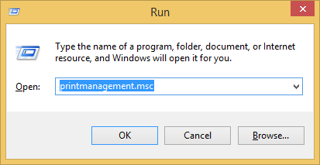
- Expand Print Servers, expand the name of your machine, and right-click on Drivers. Select Add Driver…
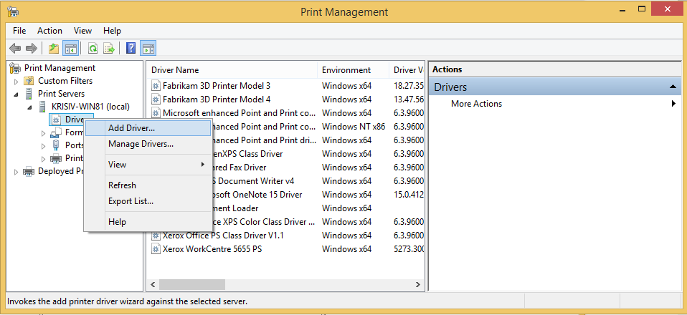
- Click Next->(x64)->Have Disk
- Navigate to the RenderFilters_x64 folder and select the MS3DPrinter.inf, then click OK.
- Click OK->Next->Finish
- From the Windows Start screen type “Devices and Printers”
- Click Add Printer.
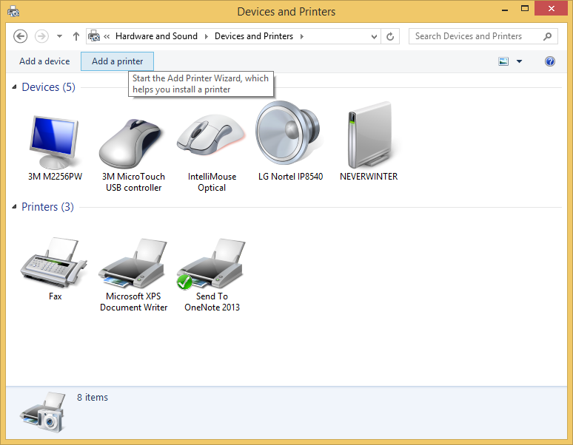
- Select “The printer that I want isn’t listed”.

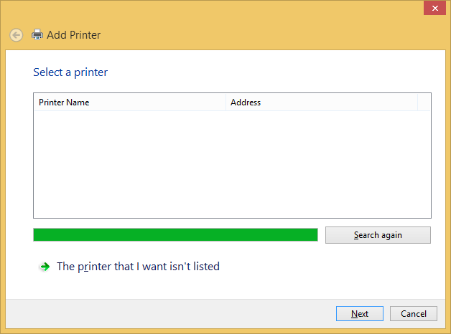

- Select “Add a local printer or network printer with manual settings” and click Next.
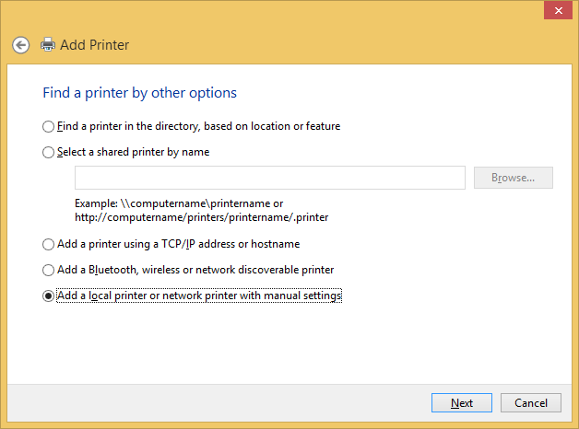
- Choose “Create a new port” and select “3D Port” for the type of port. Click Next.
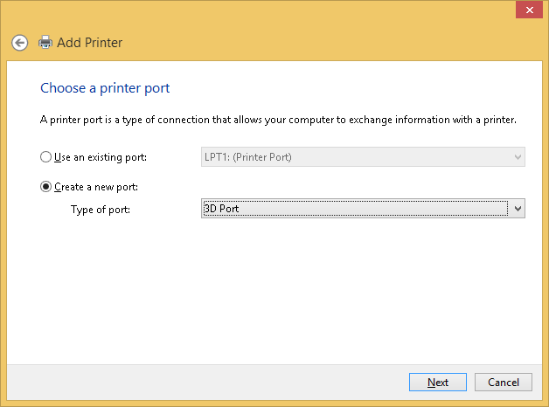
- Enter a port name and click OK.
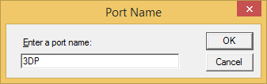
- Click Have Disk…
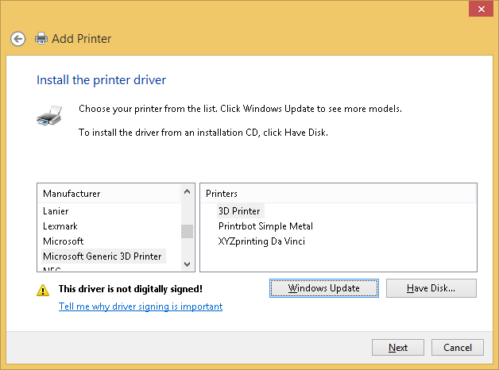
- Browse to the generic 3D Print Driver binary package from the SDK and click OK.
- Click Next
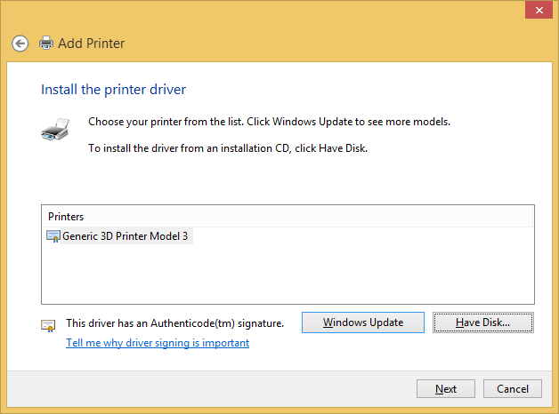
- Change the 3D printer name if you like (this will show up in print UI). Click Next. Click OK to allow the command to be run as an Administrator.
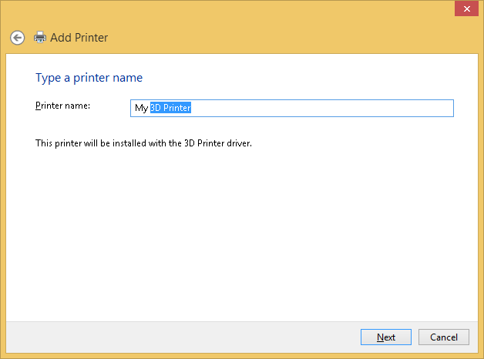
- After the installation, click Finish.

Configuring the device
At this point, you will have a 3d Printer device in the Devices and Printers control panel and can print to G-Code using the Microsoft Slicer. Next you will need to change the Slicer and advanced settings in the configuration file.
There are two configuration files:
- C:\Windows\System32\StandardGCode.XML – which is used by the StandardGCode.DLL and can change from device to device, depending on the registry mapping defined in the ConfigurationXML key under:
  - Per-printer queue: HKEY_LOCAL_MACHINE\SYSTEM\CurrentControlSet\Enum\3DPRINTER\{PrinterName}\{node}
  - Per hardware ID: HKEY_LOCAL_MACHINE\SYSTEM\CurrentControlSet\Enum\USB\{VID&PID}\{DeviceSerial}\Device Parameters\
- C:\Windows\System32\Spool\Drivers\x64\3\MS3DPrinterDeviceConfig.xml – which is global and used by the slicer.
For simplicity, edit MS3DPrinterDeviceConfig.xml file as an Administrator if using the Print to File function (G-Code file) with no physical device and edit StandardGCode.XML when printing an actual physical device.
Now you are ready to 3d Print from an app like 3d Builder in the Windows Store or the desktop 3dViewer.exe application in the 3d Printing SDK.

Slicer Settings

The configuration file contains a number of settings that may need to be adjusted for a specific 3D Printer device. These settings are described below:
Setting | Change? | Description
psk3d:Job3DOutputArea\ psk3d:Job3DOutputAreaWidth  psk3d:Job3DOutputArea\ psk3d:Job3DOutputAreaDepth  psk3d:Job3DOutputArea\ psk3d:Job3DOutputAreaHeight | Yes | Print volume in microns, defined by width (x max), depth (y max), and height (z max).
psk3d:Job3DMaterials\ psk3d:[Material]\ psk3dx:platformtemperature | Yes | The temperature (degrees Celsius) the print bed should be heated to during printing. A value of 0 means the bed should not be heated.  This value can be referenced via the $platformtemperature$ template in the pre-commands.
psk3d:Job3DMaterials\ psk3d:[Material]\ psk3dx:filamentdiameter | Yes | The diameter (microns) of the filament loaded in the 3D printer, e.g.: 1750 is standard 1.75mm filament.
psk3d:Job3DMaterials\ psk3d:[Material]\ psk3dx:filamentcalibrationoverride | Optional | A factor that adjusts the flow of filament. It is applied as a ratio of the incoming filament cross-section (based on filamentdiameter) to adjust the speed of extrusion. If this factor is greater than 1.0, less plastic will be extruded. This is a tuning parameter and should always be near 1.0.
psk3d:Job3DMaterials\ psk3d:[Material]\ psk3dx:extrudertemperature | Yes | The temperature (in degrees Celsius) the extruder/hot end should heat to when extruding.  This value can be referenced via the $extrudertemperature$ template in the pre-commands.
psk3d:Job3DMaterials\ psk3d:[Material]\ psk3dx:autocenter | Optional | A Boolean value (0 or 1) indicating whether the model should be centered on the print bed (on the XY plane).
psk3dx:customStatus | Optional | A string representing the initial print job status, typically the Slicing phase. If missing the job status will be set to “Printing”.
psk3dx:userprompt | Yes | A message displayed as the user prompt before a print begins. This prompt is used to prevent the extruder crashing into a previous print on devices that require manual removal of prints.  For devices that can display the prompt on device itself this setting is not required.
psk3dx:MS3DPrinter\ psk3dx:debug\ psk3dx:log | Optional | When present, this setting enables driver debug logging to a file.  This setting can also be turned on globally via registry key HKEY_LOCAL_MACHINE\SYSTEM\CurrentControlSet\Control\Print  StandardGCodeDebugLog=”c:\Path\To\LogFile”
psk3dx:MS3DPrinter\ psk3dx:communication\ psk3dx:connection\ psk3dx:comport | Optional | URI to a serial port name. When present this setting overrides the driver auto-resolution of the COM port (Printer Queue -> Printer Port Name -> Enum\3DPrinter\Device -> Enum\USB\Serial Device).
psk3dx:MS3DPrinter\ psk3dx:communication\ psk3dx:connection\ psk3dx:baudrate | Optional | The baud rate of the serial connection for the connected device. Typical values are 115200 or 250000.
psk3dx:MS3DPrinter\ psk3dx:communication\ psk3dx:connection\ psk3dx:mode | Reserved | This settings controls the reset on connect behavior (DTR setting). Use values of 1 or 3 if the device fails to connect.
psk3dx:MS3DPrinter\ psk3dx:communication\ psk3dx:connection\ psk3dx:timeout | Reserved | Timeout in milliseconds for printer response. Use a value of 0 (default) for no timeout.
psk3dx:MS3DPrinter\ psk3dx:customcommands\ psk3dx:initcommands\ psk3dx:command | Yes | The sequence of commands sent before slicing. These commands are executed in parallel with the slicer. This is typically a sequence of G-Code commands that home, calibrate, auto-level and/or heat up the printer to a near final temperature.
psk3dx:MS3DPrinter\ psk3dx:customcommands\ psk3dx:precommands \ psk3dx:command | Yes | The set of G-Code commands to send at the start of each job, generally to initialize the 3D printer, like homing and heating up the extruder to the final temperature and priming the extruder. Each device has different required pre-commands. Each “line” of G-Code should appear in a child <command> element. Variables that are to be replaced by the referenced setting can be declared as the name delimited by ‘$’ characters, e.g. <command>M104 S$extrudertemperature$</command>
psk3dx:MS3DPrinter\ psk3dx:customcommands\ psk3dx:postcommands\ psk3dx:command | Yes | The set of G-Code commands to send at the end of each job, generally to bring the 3D printer to a safe state, like cooling down the extruder and moving the part away from the extruder/hot end to where it's easy to remove from the bed. Each device has different required post-commands.  This sequence is also executed when a job is cancelled.
psk3dx:MS3DPrinter\ psk3dx:customcommands\ psk3dx:failsafepostcommands\ psk3dx:command | Optional | A set of G-Code commands to be sent as fail safe mechanism, for example in case of a slicer error. If missing, the driver will execute an “M110 N0” followed by “M104 S0”.
psk3dx:MS3DPrinter\ psk3dx:print\psk3dx:{quality }\ psk3dx:layerthickness | Yes | The thickness (z-height) of a layer, in microns. This value should be defined based on the machine physical resolution to minimize the positioning errors.
psk3dx:MS3DPrinter\ psk3dx:print\psk3dx:{quality }\ psk3dx:maxlayerthickness | Reserved | Maximum layer thickness (micron).  This is reserved and might be deprecated in the future.
psk3dx:MS3DPrinter\ psk3dx:print\psk3dx:{quality }\ psk3dx:minlayerthickness | Reserved | Minimum layer thickness (micron).  This is reserved and might be deprecated in the future.
psk3dx:MS3DPrinter\ psk3dx:print\psk3dx:{quality }\ psk3dx:pathwidth | Yes | The width (in the XY plane) of an extruded toolpath, in microns. A value close to and slightly larger than the nozzle diameter tends to produce best results.
psk3dx:MS3DPrinter\ psk3dx:print\psk3dx:{quality }\ psk3dx:shells | Optional | An integer number of inset shells before infill begins. A value of 1 makes only a single perimeter and a value of 0 makes only infill (very rough surface finish).
psk3dx:MS3DPrinter\ psk3dx:print\psk3dx:{quality }\ psk3dx:shelloffset | Optional | Offset of the outer shells in microns. Use this value to tune the results on models that have a very tight fit between parts (for example gears).
psk3dx:MS3DPrinter\ psk3dx:print\psk3dx:{quality }\ psk3dx:topsurfacelayers | Optional | An integer number of layers to fill solidly on the upper surfaces of the print. A value of 0 makes sparse infill visible from the top.
psk3dx:MS3DPrinter\ psk3dx:print\psk3dx:{quality }\ psk3dx:bottomsurfacelayers | Optional | An integer number of layers to fill solidly on the lower surfaces of the print. A value of 0 makes sparse infill visible from the bottom.
psk3dx:MS3DPrinter\ psk3dx:print\psk3dx:{quality }\ psk3dx:fill | Reserved | Specifies the sparse infill fraction, between 0.0 and 1.0 inclusive. 0.1 (10%) is a good default. A value of 0.0 will result in only the shells being printed and a value of 1.0 will use the solid infill pattern instead of a sparse infill.  This is reserved and might be deprecated in the future.
psk3dx:MS3DPrinter\ psk3dx:print\psk3dx:{quality }\ psk3dx:fillangle | Optional | The initial angle of the fill pattern, measured in degrees along the XY (horizontal) plane, counter-clockwise from the X-axis.
psk3dx:MS3DPrinter\ psk3dx:print\psk3dx:{quality }\ psk3dx:filloverlap | Reserved | Infill overlap (between 0 and 1 of the path width, inclusive).  This is reserved and might be deprecated in the future.
psk3dx:MS3DPrinter\ psk3dx:print\psk3dx:{quality }\ psk3dx:speed | Yes | The default speed for printing movements, in microns/s. This is the 2-norm of the X and Y axis speeds.
psk3dx:MS3DPrinter\ psk3dx:print\psk3dx:{quality }\ psk3dx:speedouter | Yes | Speed of the outer perimeter (first shell) in microns/s. This can be set lower than the normal speed to create a better surface finish on the print.
psk3dx:MS3DPrinter\ psk3dx:print\psk3dx:{quality }\ psk3dx:speedfirst | Yes | Speed of the first layer (superseding speedOuter) in microns/s. This can be set lower than the normal speed to create better print bed adhesion.
psk3dx:MS3DPrinter\ psk3dx:print\psk3dx:{quality }\ psk3dx:speedtravel | Yes | Speed of non-extrusion moves in microns/s. This can be set higher than the normal speed to minimize stringing and speed up the print when the extruder is the limiting factor.
psk3dx:MS3DPrinter\ psk3dx:print\psk3dx:{quality }\ psk3dx:speedretract | Yes | Speed of filament retraction and push-back, in microns/s. Unlike other speed settings, this is measured on the input filament, rather than on the X and Y axes. This speed is therefore about a factor of 20 smaller than the speeds above (depending on your filament). However, it can be higher than the equivalent speed, because plastic is not being forced to extrude during retraction.
psk3dx:MS3DPrinter\ psk3dx:print\psk3dx:{quality }\ psk3dx:retraction | Yes | Length of filament to be retracted, again measured on input filament, in microns. This is symmetric for retracting and pushing back and is designed to reduce stringing and oozing of the nozzle when traveling.
psk3dx:MS3DPrinter\ psk3dx:print\psk3dx:{quality }\ psk3dx:supportorientationoptimization | Reserved | A Boolean value (0 or 1) indicating whether to automatically reorient the model to minimize required support, or not.  This is reserved and might be deprecated in the future.
psk3dx:MS3DPrinter\ psk3dx:print\psk3dx:{quality }\ psk3dx:supportoverhangangle | Optional | The maximum overhang angle requiring support, measured from the horizontal plane up to the model facet, in degrees. Smaller angles create less support structure.
psk3dx:MS3DPrinter\ psk3dx:print\psk3dx:{quality }\ psk3dx:supportzgap | Yes | The Z gap in micron between the part and support. This setting can reduce the adhesion to support, making the support easier to remove.
psk3dx:MS3DPrinter\ psk3dx:print\psk3dx:{quality }\ psk3dx:supportxygap | Yes | The gap in micron between support and part in the XY plane.
psk3dx:MS3DPrinter\ psk3dx:print\psk3dx:{quality }\ psk3dx:supportfill | Optional | Sparse infill fraction for support (between 0 and 1, inclusive)
psk3dx:MS3DPrinter\ psk3dx:print\psk3dx:{quality }\ psk3dx:raftlayers | Optional | Number of solid raft layers. A number of 2 is generally sufficient but this
psk3dx:MS3DPrinter\ psk3dx:print\psk3dx:{quality }\ psk3dx:raftlayerthickness | Yes | Layer thickness (Z height) of the raft in microns.
psk3dx:MS3DPrinter\ psk3dx:print\psk3dx:{quality }\ psk3dx:raftpathwidth | Yes | Path width of raft in microns, this is generally a larger value to accommodate variations in the print bed surface.
psk3dx:MS3DPrinter\ psk3dx:print\psk3dx:{quality }\ psk3dx:raftfill | Optional | Sparse infill fraction for support (between 0 and 1, inclusive).
psk3dx:MS3DPrinter\ psk3dx:print\psk3dx:{quality }\ psk3dx:raftoffset | Optional | Size of the raft in microns.
psk3dx:MS3DPrinter\ psk3dx:print\psk3dx:{quality }\ psk3dx:raftzgap | Yes | The Z gap in micron between the raft and the object. A higher value makes the raft easier to remove, but might produce an uneven surface.
psk3dx:MS3DPrinter\ psk3dx:print\psk3dx:{quality }\ psk3dx:raftspeedfirst | Yes | Speed of raft first layer (micron/s). This should be similar or lower to speedfirst to increase bed adhesion.
psk3dx:MS3DPrinter\ psk3dx:print\psk3dx:{quality }\ psk3dx:coolingtime | Optional | Minimum cooling time for a layer (second). The layer speed is reduced such that at it prints in more than this number of seconds.
psk3dx:MS3DPrinter\ psk3dx:print\psk3dx:{quality }\ psk3dx:mincoolingspeed | Optional | The minimum cooling speed for a layer (micron/s)
psk3dx:MS3DPrinter\ psk3dx:print\psk3dx:{quality }\ psk3dx:bridgingspeed | Yes | The speed of extrusion during bridging in microns. This value depends on factors such as machine cooling characteristics and filament type and is typically slower than normal printing speed.

Note: In the print node’s settings (psk3dx:MS3DPrinter\ psk3dx:print\psk3dx:{quality }\), the {quality} element name is replaced by one of the corresponding psk3d:Quality Print Schema 3D Keyword (see separate specification) settings sent in the PrintTicket along with the print job. This allows each quality level to define its own set of slicer settings. If the PrintTicket is omitted, the slicer will use the [quality] setting marked with the attribute default=“true”, so exactly one quality level should always define this attribute

